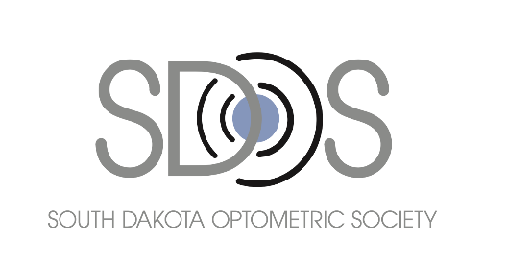
2023 South Dakota Optometric
Society Scholarships

We invite you to apply for the South Dakota Optometric Society scholarships, which will be awarded in September 2023. Please follow these application instructions and submit all materials by 5:00 p.m. CDT on Thursday, August 31, 2023.

Eligibility Requirements

- The applicant must have completed pre-optometry professional school education requirements.
- The applicant must be a second- or third-year optometry student attending an accredited school of optometry for the fall 2023 term.
- The applicant must be a resident of the state of South Dakota.
- Award of scholarship will be based primarily on grade point average (undergrad GPA of 3.5 and above, and graduate GPA of 3.0 and above).
- Amount of award will vary depending on number of applicants and will be set by the SDOS Board each year.
- Student awarded a scholarship in 2022 is not eligible to apply this year.

Application Process

- Complete the Application Form.
- Write a short essay (300 words or less) explaining your interest in optometry and attach this sheet to your application form.
- Write a short essay (100 words or less) describing your need for a scholarship and attach this sheet to your application form.
- Request that applicable transcripts from the following institutions be sent directly to the South Dakota Optometric Society:
- College (all undergraduate)
- Optometry school (all work completed to date)

If you wish to apply for these scholarships, please carefully follow the instructions and forward all required documentation no later than August 31, 2023 to:

SDOS
PO BOX 1173
Pierre, SD 57501

Material may also be submitted electronically to: deb.mortenson@pie.midco.net

If you have questions, please call 605-224-8199 or email deb.mortenson@pie.midco.net.

2023 South Dakota Optometric Society
Scholarship Application

All information submitted is confidential and for the use of the selection committee only.

Full Name_________________________________ Date________________________

Present address ________________________ Phone_______________________

Permanent address_________________________ Phone_______________________

Email Address___________________________________________________________

Birthdate______________________________ Birthplace_______________________

Male_____ Female______ Single________ Married________

Number of dependents ___________________________________________________

How long have you lived in South Dakota? ____________________________________

Father’s name_________________________ Occupation________________________

Mother’s name ________________________ Occupation _______________________

Number of siblings in college: _______________________________

Have you applied for or are you receiving any other financial aid?

Describe_______________________________________________________________

Please list schools attended and degrees received: _____________________________

______________________________________________________________________

Which school of optometry are you attending this fall?
______________________________________________________________________

Signature
________________________________________________

